**Ansible in Aws**

Create two virtual Linux machines in AWS .as below

1 Ansible server (master)

2 Ansible1 (Slave)

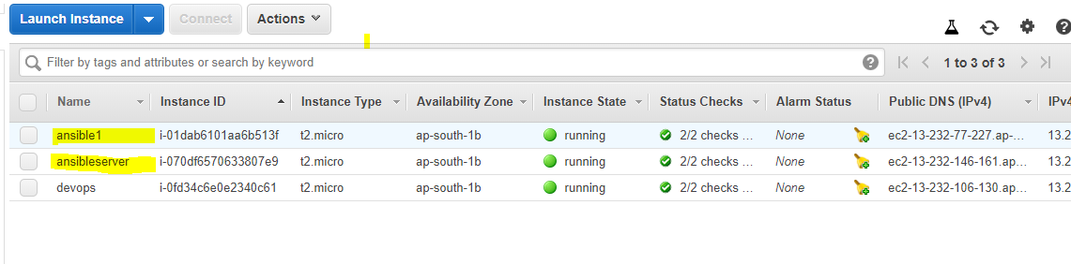 Installation of Ansible in Server

1. Login to server machine

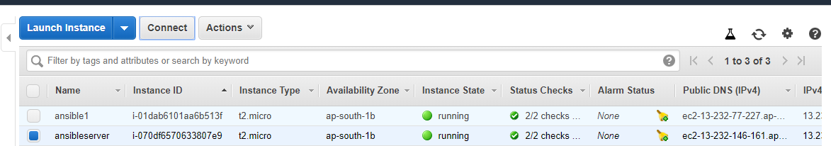

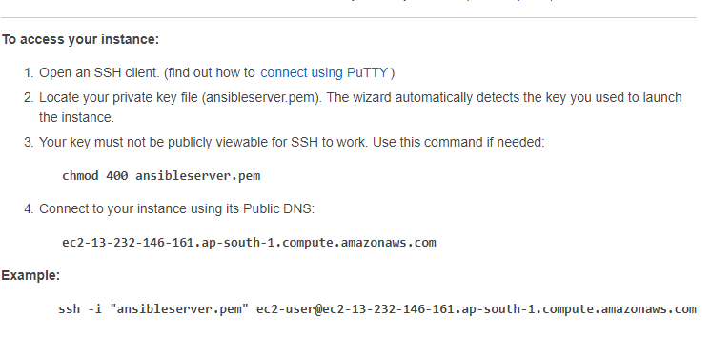

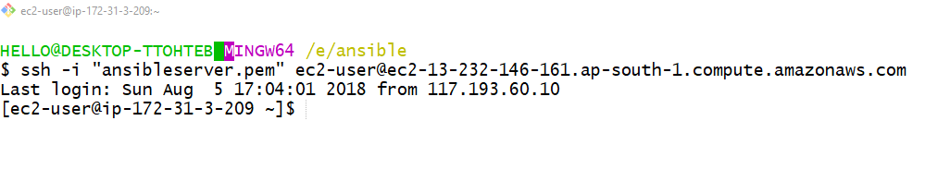2. Please follow the below instructions for Ansible installation.

* sudo rpm -Uvh <https://dl.fedoraproject.org/pub/epel/epel-release-latest-7.noarch.rpm>
* sudo yum -y install ansible

Note: Please follow the below instruction for installation of ansible for Ubuntu machine

* sudo apt-get update
* sudo apt-get install software-properties-common
* sudo apt-add-repository ppa:ansible/ansible
* sudo apt-get update
* sudo apt-get install ansible

1. SSH connections between server and node

//In ansible server

ssh-keygen // it will be in a directory /home/



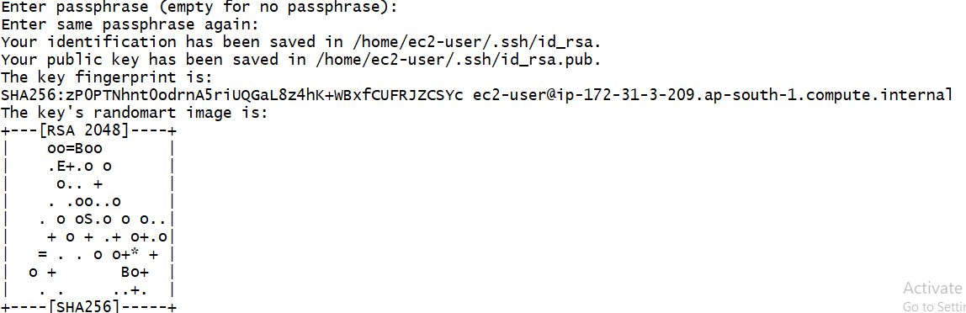

ls –la //to list hidden files and folders - it will show .ssh folder

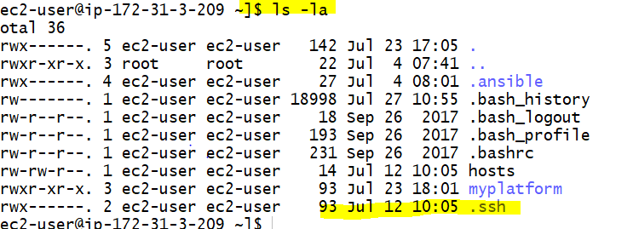

cd .ssh // changing the directory to .ssh - it will show generated private and public key

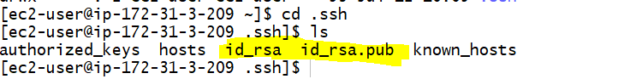

vi id_rsa.pub (or) cat id_rsa.pub //copy the public key



Go to Node machine

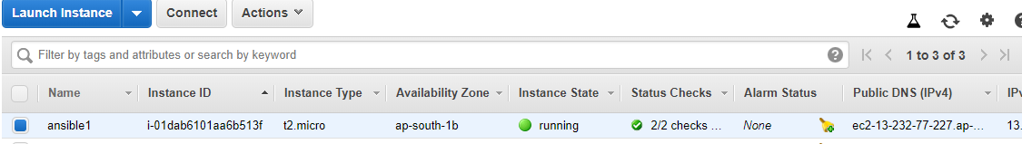

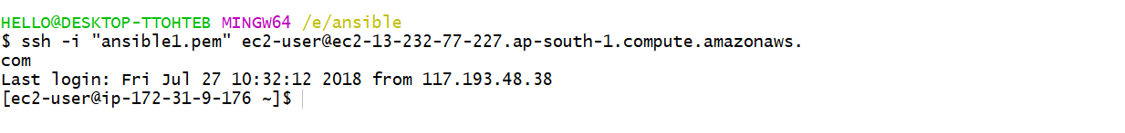

sudo -s //to obtain a admin rights or login through root user

cd /root //change the directory to root folder

cd .ssh //change the directory to hidden .ssh folder

ls //to view the authorized_keys file

vi authorized_keys //paste the key

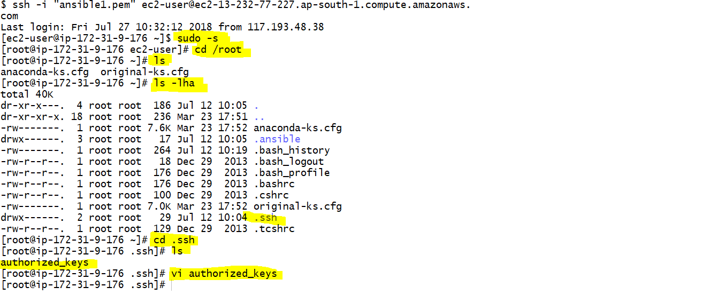

//Paste the key inside authorized keys folder, then save it “:wq”



Go back to ansible server machine and open hosts file

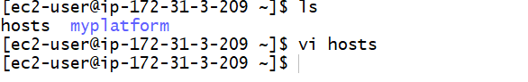

Inside the hosts file please insert the IP of node machine

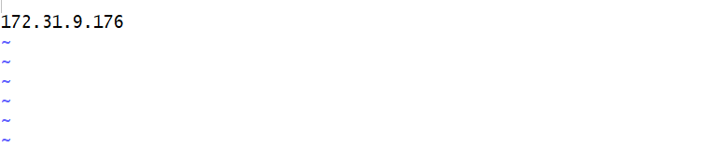

Please give the below commands to connect the server and node

ansible -i hosts -u root -m ping all

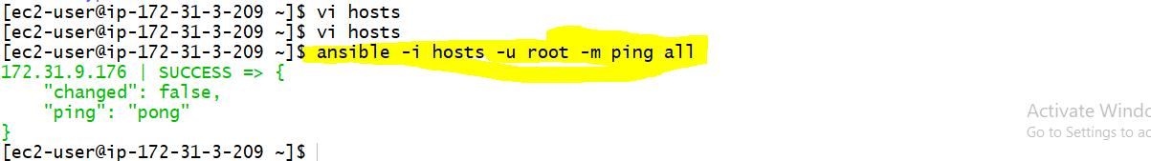

Configuring ansible in server machine, Please follow the instructions

//to view the ansible core files

ls -lha /etc/ansible

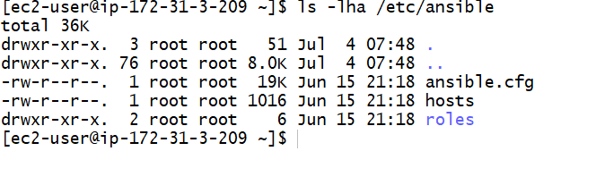

// copy the ansible core files into myplatform directory

cp -R /etc/ansible myplatform

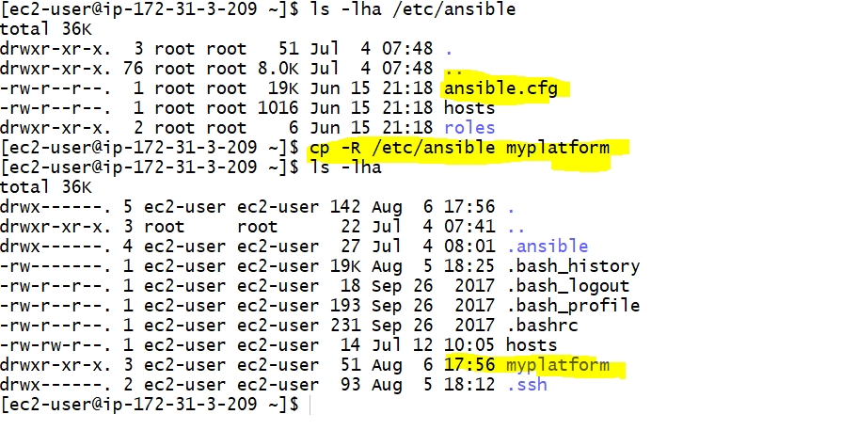

// change the directory to myplatform

cd myplatform

// confirm all the core files or copies to myplatform

ls -lha

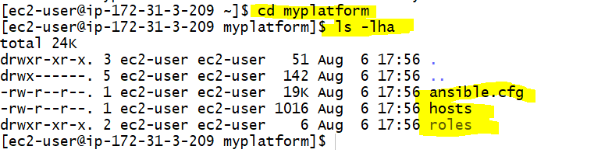

//In Ansible server - Creating configuration in myplatform directory

vi ansible.cfg

inventory = hosts //uncomment inventory and change the hosts path

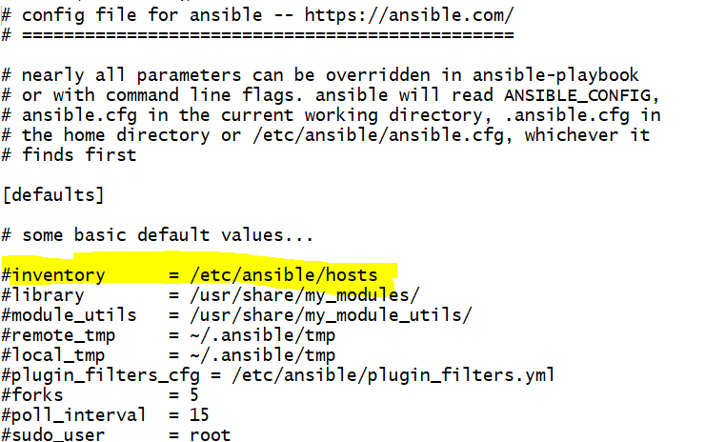

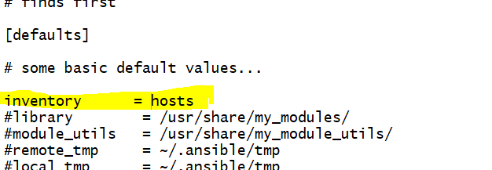

// open the hosts file in editor

vi hosts

// insert ip address of node1 ,

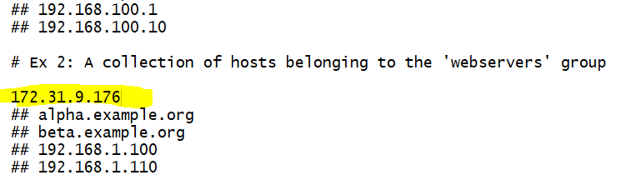

Steps for Creating Main.YML file

//change the directory to myplatform

cd roles //change the directory to roles

mkdir basic // create a directory called basic

cd basic //change directory to basic

mkdir tasks // create a directory called tasks

cd tasks //change the directory to tasks

vi main.yml // create a main.yml file using vi editor



Inside the main.yml file , Please below enter the below scripting

- name: "Installing Vim"

apt: pkg=vim state=installed

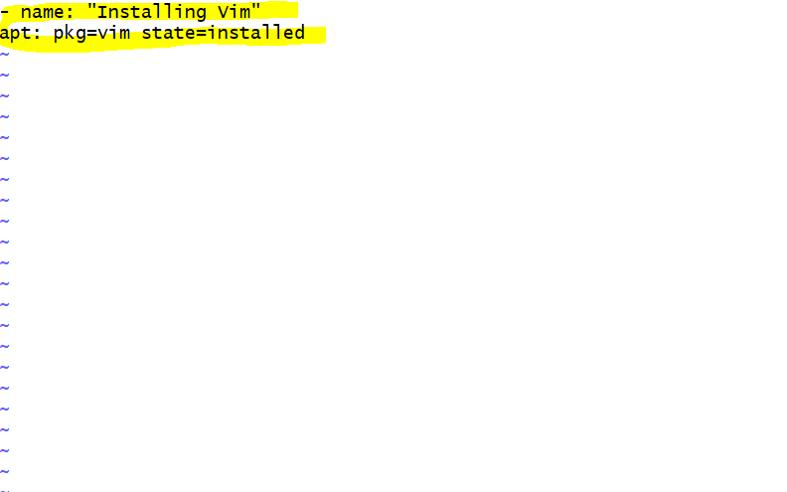

Instructions for creating play book.yml

// Go to myplatform directory or home directory - Create a playbook.yml

// it need to be created in myplatform directory

vi playbook.yml // to create a new playbook.yml file using vi editor



//IN playbook.yml file -paste below commands

---

- hosts: all

become: true

roles:

- basic

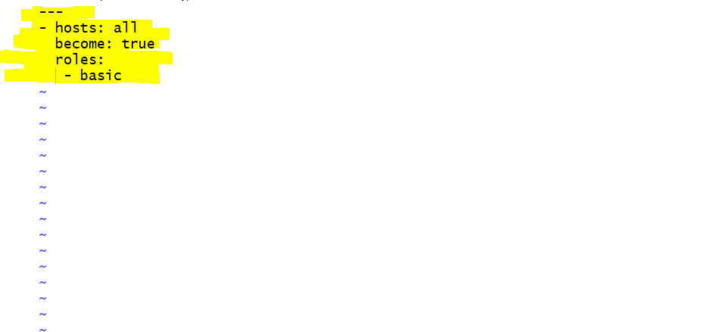

// Run playbook.yml using following command - verify you are in myplatform directory

ansible-playbook -u root -s playbook.yml

